SOP: Setup Dynamic Study tablet

Purpose and scope
In this document, you will learn how to perform the basic setup of android devices.
NB: this procedure is based on a Lenovo tablet. Changes occur when configuring tablets from other brands.

Responsibilities and Procedures

Material Needed
- 8’ Android Tablet (running Android 9 or 10)
- A Wi-Fi with an internet connection
- The IT Coordinator with the Master Tablet to allow the Android Parental control
  - Reminder: (never share this with the users!!!)
  - U: dynamic.study.tz.adm@gmail.com
  - P: This-Is-Dynamic-Study-Admin-Mail

Android Setup (Lenovo Tablet)
- Charge the tablet’s battery until it reaches 100%
- choose English and press “Start”
- Agree to the License Agreement
- Skip the Wi-Fi Connection for now (confirm it)
- Setup date and time
- Accept the terms
- Skip the tablet locking process (Not Now & Skip Anyway)
- Skip Face Recognition
- Skip Lenovo ID
- Accept User Experience Program
- Choose the classic mode for the navigation Method
- You should now have access to Android
- Set screen timeout to 30min

Android Setup (Samsung Tablet)
- Charge the tablet’s battery until it reaches 100%
- choose English and press “Start”
- Agree to the License Agreement
- Skip the Wi-Fi Connection for now (confirm it)
- Setup date and time
- Accept the required terms, do not accept terms that are optional
- Skip Samsung account creation
- Skip security settings such as locking process
- You should now have access to Android
- Set screen timeout to 30min:
  - Open the Settings app, navigate to Display and set Screen timeout to ‘After 30 minutes of inactivity’
- De-activate auto-correct:
  - In Settings select general management, Select Samsung Keyboard, and then take off “Predictive text”.

MedAL-reader Setup
- Go to settings → Wi-Fi → Connect the Wi-Fi “Dynamic Study” with the code “Dyn@m11c”
- Go to “Play Store”
- Sign in with:
- E-Mail: dynamic.study.tz@gmail.com
- Password: 123456
- Agree to the terms
- Do NOT backup the device to Google Drive (untick)
- Open the Play Store and search for the ‘medAL-reader’ app from ‘Unisanté’
- Install the app and start it
- On the login page, enter:
- E-Mail: dynamic.study.tz@gmail.com
- Password: 123456
- Start the app and accept all permissions it may request
- On the login page, enter:
- E-Mail: dynamic.study.tz@gmail.com
- Password: 123456

Respiratory Rate App Setup
Go to “Play Store”
Search the play store for “RRate”
Click on and Install the first one (from “PART BC Children’s”) (Accept any permissions it may request)

ODK Collect for Registration Assistant tablet
- Go to “Play Store”: Search the play store and download “ODK Collect”
- Upload the eligibility ODK form from: SWITCH drive folder 3.12: Summary Form

RedCAP app:
-

Setup Parental control (If Android did not when logging in with Dynamic Mail)
To execute these steps, you must be able to communicate with your local IT Coordinator to receive the authorization to install the tablet.
- Go to Android Settings
- Click on the search bar
- Enter “Parental Control”
- Click on “Digital Wellness & Parental Control”
- Follow the written steps to enable the Parental Control

Apps Management using family link Parent App
- Open the Family Link App in the Master Tablet
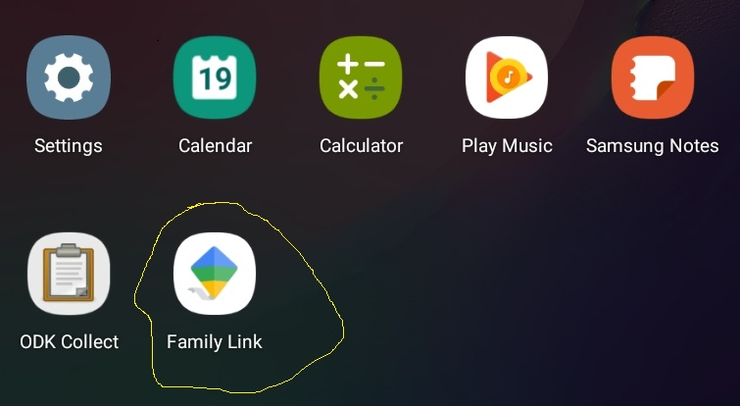

- Click View
- Go to the Manage Settings→Android apps
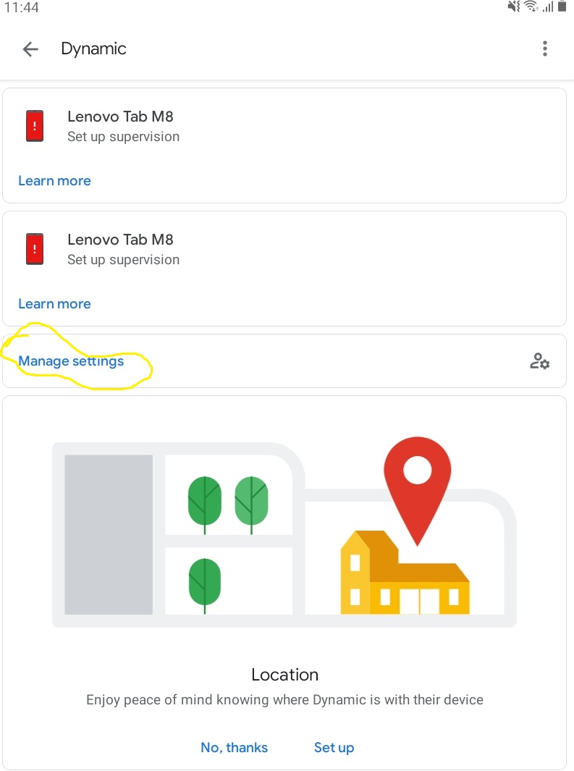
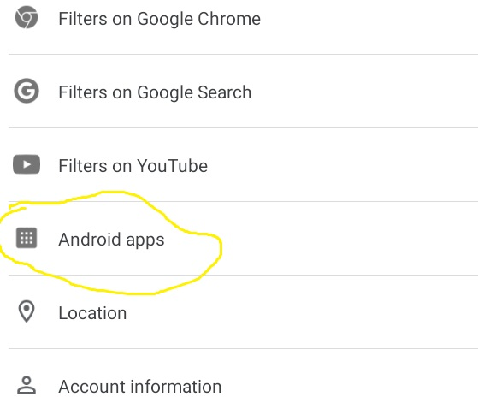

- Select any apps
- Turn on or off allow app Or Manage Permission.
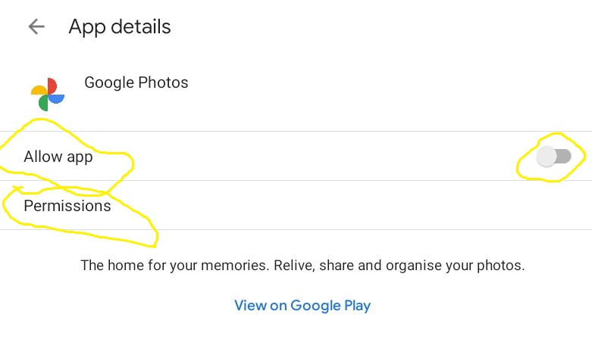

List of allowed Android applications
- MedAl_reader
- RRate
- ODK Collect
- RedCAP
- QR and Barcode Scanner
- Camera
- Play store
- Calculator
- Office Mobile
- PDF reader
- Google Calender

Remote Support Software Setup
To test Google Meet with multiple tablets

Set MAC address to physical tablet MAC address rather than virual MAC address associated to router. -> see SOP DYT_IT_10

Download relevant PDFs found in Switch drive folder 2.2.3

Administrative information

 | Name | Signature | Date
Author | Léon Surbeck |  | 27.10.2020
Revised by
Approved by

Document change control:
Version | Changes | Name | Date
01 | New Document | Léon Surbeck | 27.10.2020

Distribution of SOP:
Name | Role | Health facility / Institute | Date
*Note: When printing and distributing the SOP, the administrative information page does not need to be included.

