How to setup tablet screen mirroring

### Introduction

In this document, you will learn how to install and use the free and open source tool “scrcpy”.

This tool lets you mirror and control an android device from a PC. It can be used at the registration desk of a health facility and avoid the nurses having to switch constantly from the PC to the tablet.

### Device setup

To use this tool, you will need to change settings in your device:

1. Go to your device’s settings (little gear icon when you pull from the top of the screen)  
   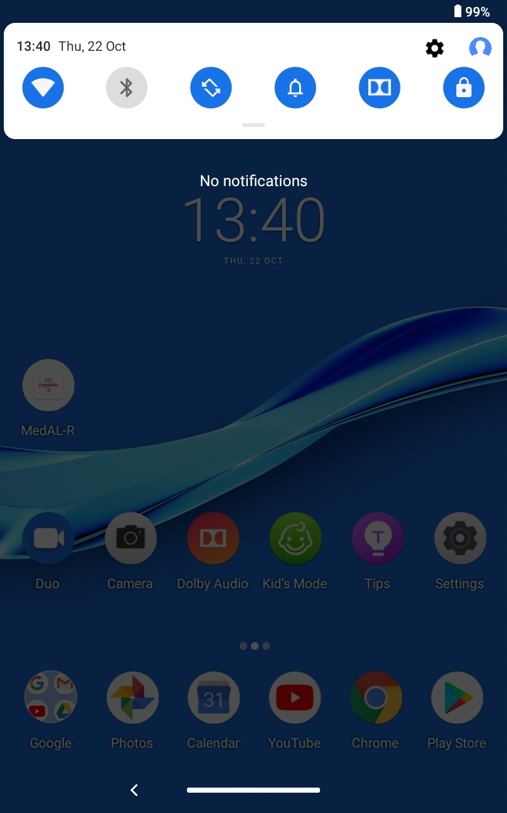
2. Go in the “System” tab  
   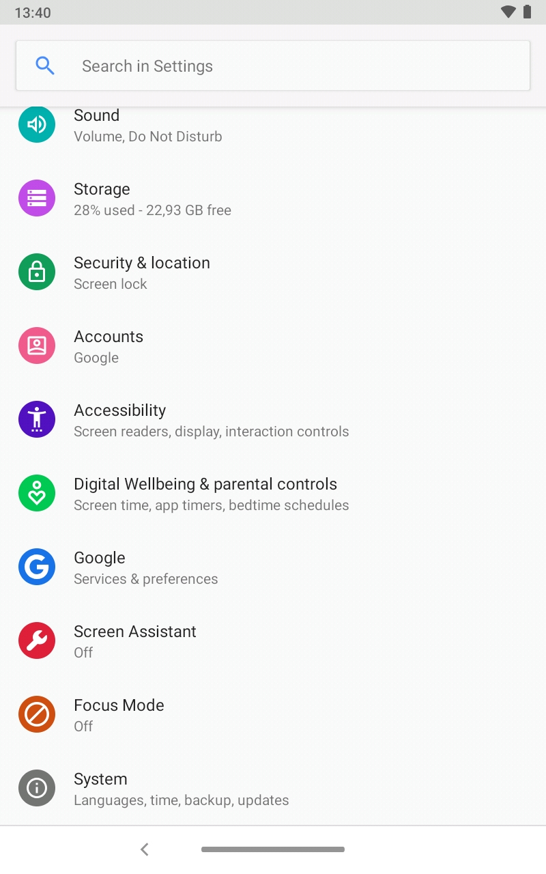
3. Go in the “About” tab  
   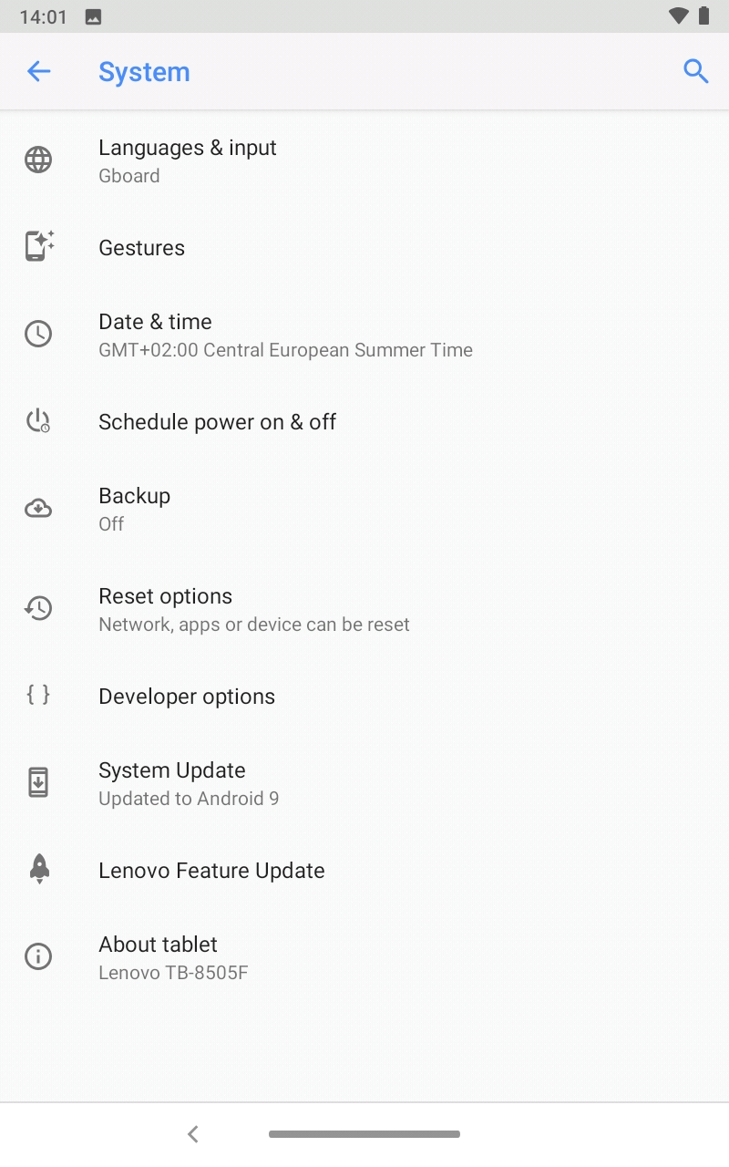
4. Press on the “Build number” 10 times until you see a message saying you activated developer options  
   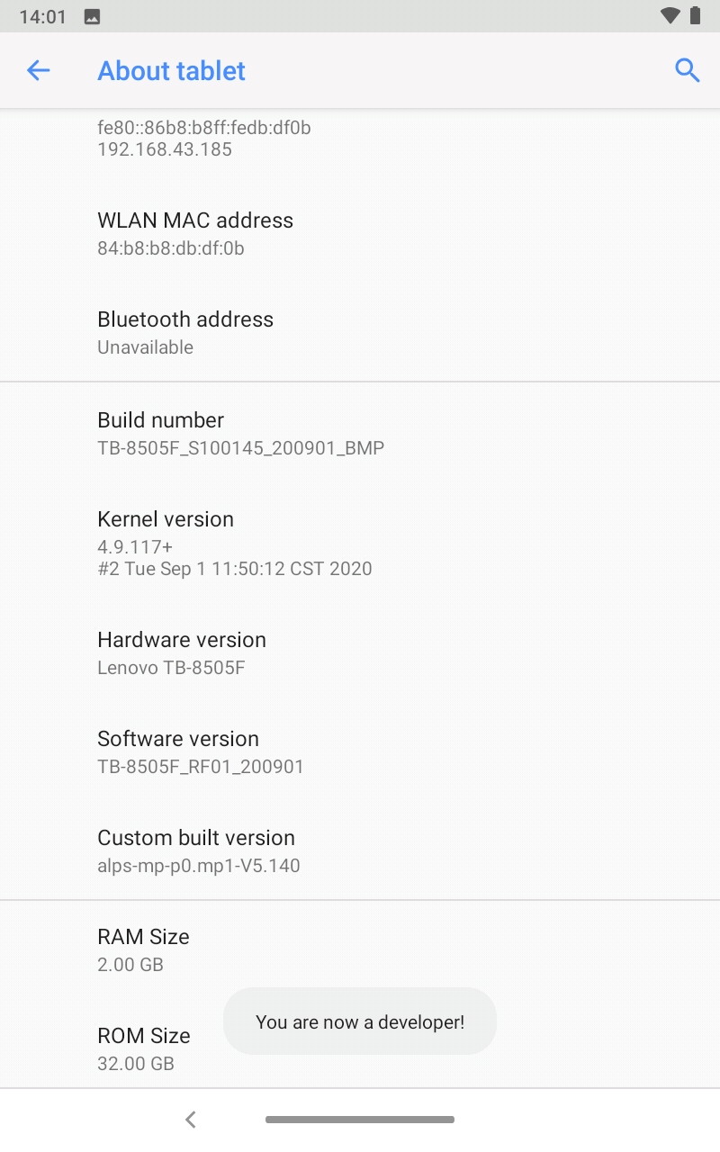
5. Go back and then in Developer options  
   
6. In here, activate “USB Debugging” and confirm the popup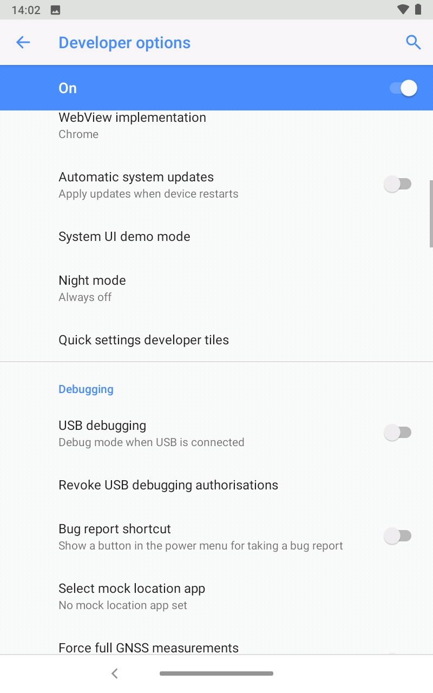  
   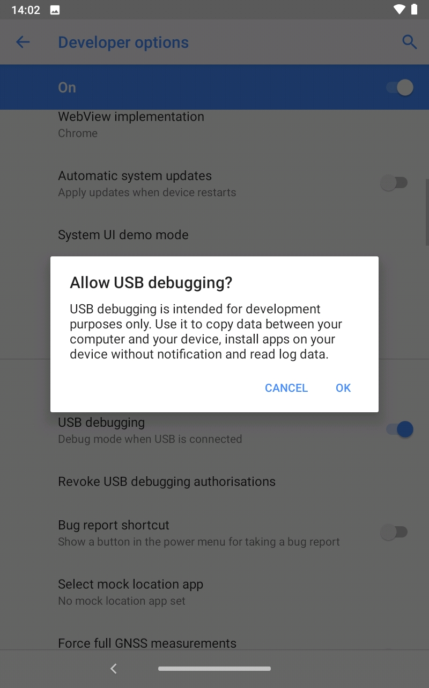
7. You are done, go back to the home screen

Note: For some tablet the setting arrangements are not the same like the procedure above. So If the arrangement of your tablet is different from the above feel free to go with the different procedure to perform the same operation as above

### PC setup

Download the tool: open your browser and navigate to <https://github.com/Genymobile/scrcpy>

Scroll down until you find this link (version may change) and click on it:

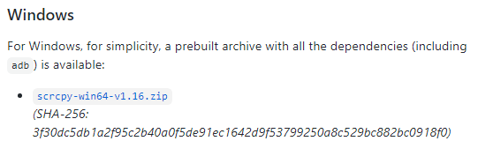

If there is a popup, confirm the download

Then, head to where the file was downloaded (Usually C:\Users\<YourUserName>\Downloads)  
and unzip the download (right click → extract all)

The extracted folder should look like this:

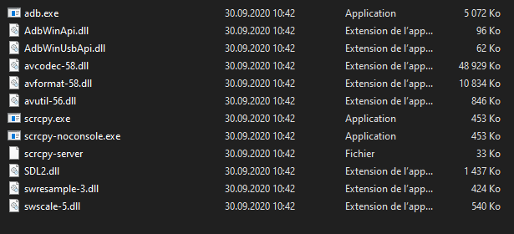

### Run the tool

Make sure the Android device is plugged in the computer via USB

Open the folder you extracted the tool in

Double click on “scrcpy.exe” you should see a popup on the Android device, click “Allow”

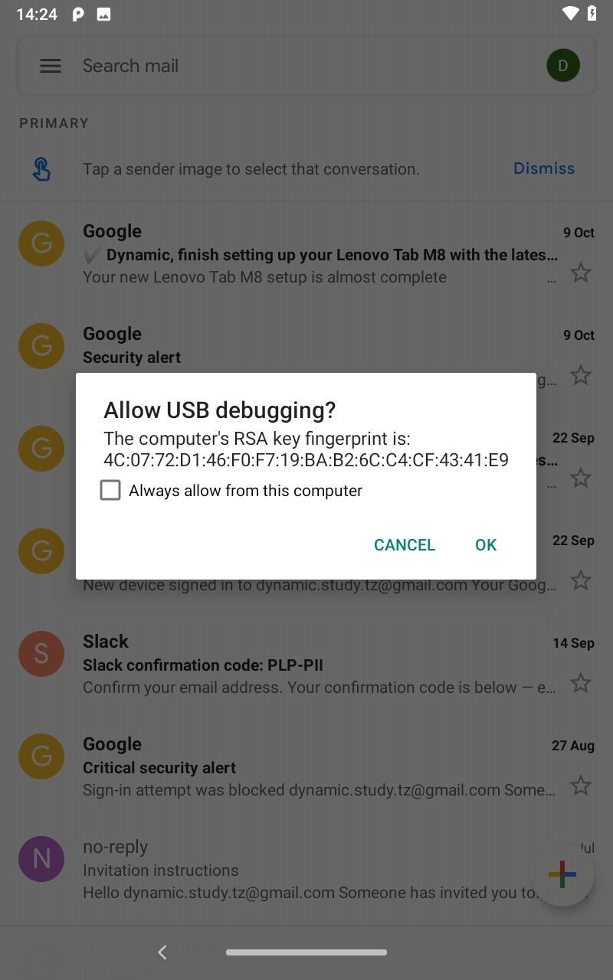

The device screen is now mirrored and controllable from the PC

Working in the PC screen some operation like copy and paste are working only by using keyboard shortcut keys which are; Ctrl-C for copy and Ctrl-P for paste